  - FACTSHEET: OECD DAC Disability Policy Marker and its application in Switzerland’s ODA reporting

Summary

Switzerland started applying the policy marker on inclusion and empowerment of persons with disabilities (hereafter ‘disability marker’) for data in 2018 and has since also marked 2019 data. The data shows whether and to what extent Switzerland’s development projects and programmes aim to be disability inclusive. Data from 2019 suggests that only 3% of all Swiss development projects aimed to be disability inclusive. More needs to be done to ensure consistent and quality marking of projects. In fact, in 2019, only 13% of all Swiss development projects were screened for disability inclusion at all. In comparison, almost 100% of all Swiss projects were screened and marked using the gender equality policy marker.

Background

The disability marker is a statistical tool of the OECD Creditor Reporting System (CRS), approved in 2018. OECD countries can assess disability inclusion of their projects and programmes. The tool also allows for more transparency on how much funding is dedicated to disability inclusion. Importantly, it provides an additional tool and incentive for countries to ensure that all projects are looked at through a disability lens.

In December 2020, the OECD released an official Handbook for data reporters and users of the disability marker. The Handbook outlines the following criteria for the marking of projects:

2: disability inclusion is the principal objective, meaning the project would not have been undertaken at all without the disability objective

1: disability inclusion is a significant objective, meaning the project would not have been undertaken in that way without the disability objective

0: the project has been screened for disability inclusion, but does not target disability inclusion in any significant way

“blanks”: the development partner did not assess this spending for disability inclusion

It must be noted that the disability marker does not measure the impact or outcome of a project. Data is collected on the “inputs” of development cooperation activities, based on project descriptions. It is not linked to results frameworks, impact indicators or evaluations. However, projects marked as targeting disability should also include indicators to track the outcomes and impact of disability inclusion (see recommendations). This is also recommended, for example, as a minimum criterion for the gender equality policy marker.

Furthermore, the marking of a project does not represent an exact quantification of the financing to disability inclusion. Rather, the financing can be interpreted as a ‘range’ of volume from lower bound (total sum of all projects marked as 2) to upper bound (total sum of all projects marked 1 and 2). In other words, the total sum of all projects that aim to be disability inclusive, does not represent the total funding going toward disability inclusion.

Analysis, OECD Data Switzerland

The 2019 data shows that 41.8 million dollars out of around 2 billion dollars total allocable ODA spending, or 2.1% of Switzerland’s allocable ODA financial spending aims to be disability inclusive. The data gives an upper estimate of how much spending is disability inclusive and does not represent the total funding going toward disability inclusion.

Switzerland did not classify over 80% of its allocable ODA spending using the disability marker. Out of a total of 5’998 projects, only 160 aimed to be disability inclusive. That’s 3% of all projects, a slight increase from only 1% in 2018.

A total of 13% of all projects (769 projects) were marked using the disability marker, a decrease from 32% in 2018. This includes those that were screened for disability, marked 0 (609 projects). 87% of all projects (5229 projects) were not marked at all, an increase from 68% in 2018. In comparison, countries such as Australia, Austria, Italy and the UK marked significantly more projects with the disability marker than Switzerland in 2019.

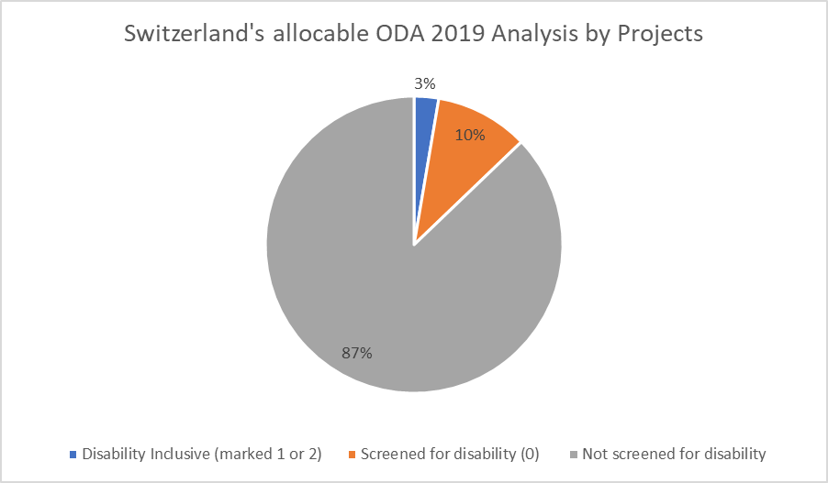

In terms of the countries in which the most disability inclusive projects aimed to have been implemented, it can be noted that most disability inclusive projects were aimed to be implemented in Myanmar and Afghanistan. A large share of disability inclusive projects were also implemented via bilateral/global contributions, not specific to a country (ex. global campaigns).

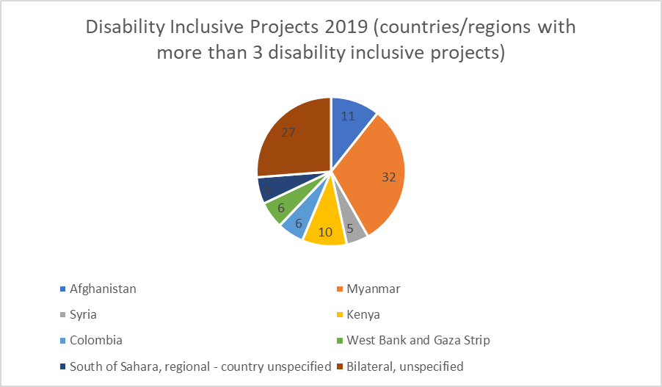

There was also a notable difference in the number of projects that were marked for SDC projects versus projects from Swiss cantons and municipalities. In total number, there were about an equal number of projects, but the cantons and municipalities marked more projects as ‘2’ than the SDC.

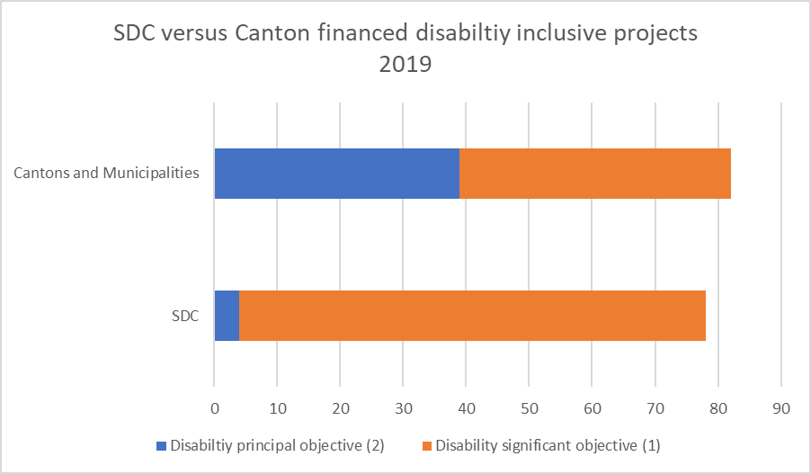

Conclusion and Recommendations

Switzerland does not yet apply the disability marker comprehensively across its ODA spending. These was inconsistency in its reporting between 2018 and 2019, where despite an apparent increase in total amount of spending on disability inclusion, less projects were marked.

With only 13% of project being marked against the disability marker, Switzerland has much to improve in terms of its reporting. It should aim to achieve the marking of 100% of its development projects, as is the case with the gender marker for example.

All projects, even if not targeting disability inclusion specifically, should at the minimum be marked as zero. However, zero cannot be used as a default value without having been screened for disability inclusion first. Proper screening is essential to ensure that at minimum projects do not perpetuate or exacerbate the discrimination and exclusion of persons with disabilities. Switzerland should use the marker as an opportunity to screen out any activities that do harm, discriminate or further segregate persons with disabilities.

Applying the marker should serve as a quality control for Switzerland’s development and humanitarian projects, to ensure that no project contravenes the basic principles of the Convention on the Rights of Persons with Disabilities, especially Article 3, as outlined here:

A ‘0’ marking should ensure:

(a) Respect for inherent dignity, individual autonomy including the freedom to make one's own choices, and independence of persons;

(b) Non-discrimination;

(c) Full and effective participation and inclusion in society;

(d) Respect for difference and acceptance of persons with disabilities as part of human diversity and humanity;

(e) Equality of opportunity;

(f) Accessibility;

(g) Equality between men and women;

(h) Respect for the evolving capacities of children with disabilities and respect for the right of children with disabilities to preserve their identities.

By applying this method for quality control, Switzerland will be able to see which projects (if any) further discrimination or segregation of persons with disabilities. These projects would not be marked at all with the disability marker.

There is also inconsistency in marking between the federal and the cantonal level. Significantly more projects were marked with disability as a principal objective in the cantons, suggesting a review needs to take place on whether the criteria for marking the projects are interpreted the same and correctly across the SDC and cantons.

The SDC should ensure the training of its staff responsible for the proper and quality marking of projects for disability inclusion. It should also ensure coordination with cantons and municipalities, to ensure consistency in the marking of projects across all of Switzerland’s development aid. Clear and consistent guidance should be provided on how to mark projects.

Lastly, to allow for the measuring of the impact of projects marked as targeting disability (marked 1 or 2), Switzerland should include in their project monitoring frameworks appropriate indicators to monitor the results of disability inclusion. These indicators are essential to monitor the impact of the activities on persons with disabilities. The use of the human rights indicators of the Office of the United Nations High Commissioner for Human Rights (OHCHR) on the CRPD is recommended.

Links and Information

OECD (2020). The OECD-DAC policy marker on the inclusion and empowerment of persons with disabilities: Handbook for data reporters and users

Polly Meeks (2020). Getting the data: How much does aid money support inclusion of persons with disabilities?

OECD DAC Creditor Reporting System.

SDC Project Database.

OHCHR (2020). Human Rights indicators on the Convention on the Rights of Persons with Disabilities

Polly Meeks (2021). Factsheet on CRPD implementation in SWITZERLAND, with a focus on disability inclusiveness of development and humanitarian aid.

OECD-DAC Network on Gender Equality (GENDERNET) 2016. Definition and minimum recommended criteria for the DAC gender equality policy marker.
Communication by the OECD on policy markers generally only takes into consideration allocable funds. Allocable aid excludes any activities for which the final allocation of funds cannot be determined. In the CRS system, allocable aid can be filtered through the data field ‘type of aid’. For the specifics on which data is filtered, see the OECD Handbook.
We analysed the OECD Creditor Reporting System database. We used 2018 and 2019 data, on a commitments basis, in current prices. We excluded negative commitments and non-allocable spending. Where development partners classified spending as “2” or “1” using the disability marker, we treated that spending as aiming to be disability inclusive.
Please consult the OECD DAC Creditor Reporting System for more details on the reporting of these countries.

